|  |
| --- |
|  |
|  |
| Content Authoring Guide |
|  |
| 4-6 Release |
|  |
|  |
|  |
|  |

|  |
| --- |
|  |

# List of content pages to be published in CQ

The following list will be used to submit a request, via Service Now, to the Operations team.

|  |  |
| --- | --- |
| Content Files Path | |
| **Desktop** | |
| /content/mytmobile/en/desktop/home/jcr:content/leftcol-parsys/checklist | Dependent on Release Yes  No |
| /content/mytmobile/en/desktop/home.html | Dependent on Release Yes  No |
| /content/mytmobile/en/desktop/plans/jcr:content/header-parsys/tour | Dependent on Release Yes  No |
| content/mytmobile/en/desktop/plans.html | Dependent on Release Yes  No |
| Mobile | |
| /content/mytmobile/en/mobile/home/jcr:content/contentarea/checklistPage | Dependent on Release Yes  No |
| /content/mytmobile/en/mobile/home.html | Dependent on Release Yes  No |
| /content/mytmobile/en/mobile/plans/jcr:content/contentarea/tour | Dependent on Release Yes  No |
| content/mytmobile/en/mobile/plans.html | Dependent on Release Yes  No |
| /content/mytmobile/en/desktop/billing/summary/jcr:content/contentarea/billingsummary | Dependent on Release Yes  No |
| Page URL : / content/mytmobile/en/desktop/billing/summary.html | Dependent on Release Yes  No |
| **Dam** |  |
|  | Dependent on Release Yes  No |
| **Tmo-Commons** |  |
|  | Dependent on Release Yes  No |

Contents

List of content pages to be published in CQ 1

US33876: [Go Big] Onboarding - (Desktop) Welcome/Checklist Modal 4

Desktop Page Content Path: 4

Before snapshot: 4

Steps to author this update: 5

US25112: [Go Big] Onboarding - (Mobile) Welcome/Checklist Modal 9

Mobile Page Content Path: 9

Before snapshot: 9

Steps to author this update: 10

US45081: [Go Big] Onboarding - (Desktop) Plan Tour - Plan Summary 13

Desktop Page Content Path: 13

Steps to author this update: 13

US45084 [Go Big] Onboarding - (Mobile) Plan Tour - Plan Summary 22

Mobile Page Content Path: 22

Steps to author this update: 22

US43644: [Go Big] Onboarding - (Desktop) EasyPay Tour - Sign up Modal 30

Desktop Page Content Path: 30

Steps to author this update: 30

US44941: [Go Big] Onboarding - (Mobile) EasyPay Tour - Sign up Modal 33

Desktop Page Content Path: 33

Steps to author this update: 33

US39701: [Go Big] Onboarding - (Desktop) Bill Tour - Beginning of Tour 37

Desktop Page Content Path: 37

Steps to author this update: 37

US39764: [Continued] [Go Big] Onboarding - (Desktop) Bill Tour - Account/Line Selector Step #1 (Multi-line only) 42

Desktop Page Content Path: 42

Steps to author this update: 42

US41486: [Continued] [Go Big] Onboarding - (Desktop) Bill Tour - Account/Line Selector Step #2 (Multi-line only) 46

Desktop Page Content Path: 46

Steps to author this update: 46

US42941: [Go Big] Onboarding - (Mobile) Bill Tour - Beginning of Tour 50

Mobile Page Content Path: 50

Steps to author this update: 50

US43202: [Go Big] Onboarding - (Mobile) Bill Tour - Account/Line Selector Step #1 (Multi-line only) 54

Mobile Page Content Path: 54

Steps to author this update: 54

US43204: [Go Big] Onboarding - (Mobile) Bill Tour - Account/Line Selector Step #2 (Multi-line only) 58

Mobile Page Content Path: 58

Steps to author this update: 58

US44944: [Go Big] Onboarding - (Desktop) Bill Tour - Highlight Line Items 62

Desktop Page Content Path: 62

Steps to author this update: 62

US44945: [Continued] [Go Big] Onboarding - (Mobile) Bill Tour - Highlight Line Items 67

Mobile Page Content Path: 67

Steps to author this update: 67

# US33876: [Go Big] Onboarding - (Desktop) Welcome/Checklist Modal

## Desktop Page Content Path:

* /content/mytmobile/en/desktop/home/jcr:content/leftcol-parsys/checklist
* Page url : /content/mytmobile/en/desktop/home.html

### Before snapshot:

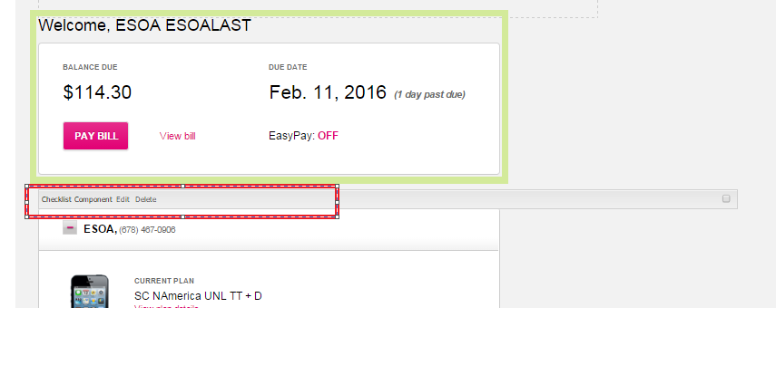

**After snapshot:**

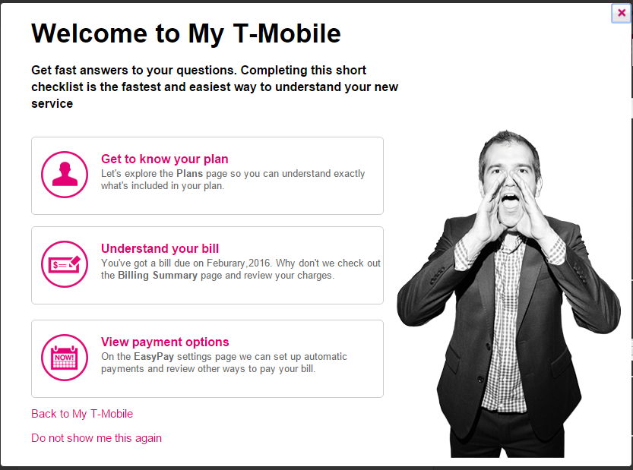

### Steps to author this update:

* Login into CQ author and go to site-admin console
* Navigate and click on “My T-Mobile | ” in site-navigation left pane under :
* Websites>mytmobile>English>Desktop>home.
* Double Click on the highlighted Page I, My T-Mobile | Home

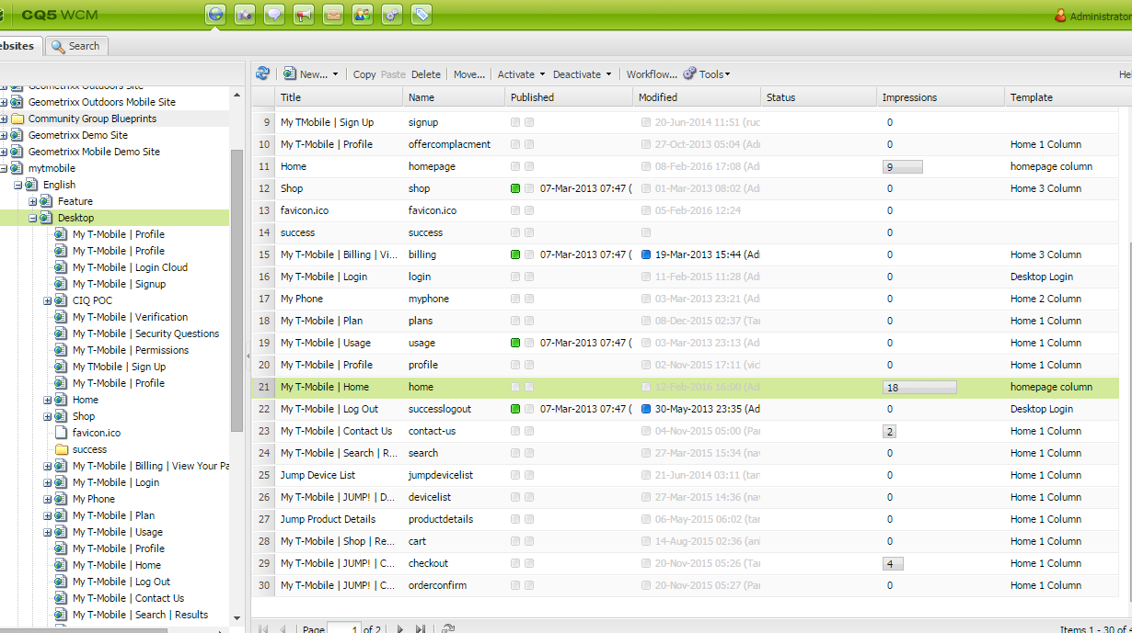

* Click on the edit option of the checklist component.

**Checklist:**

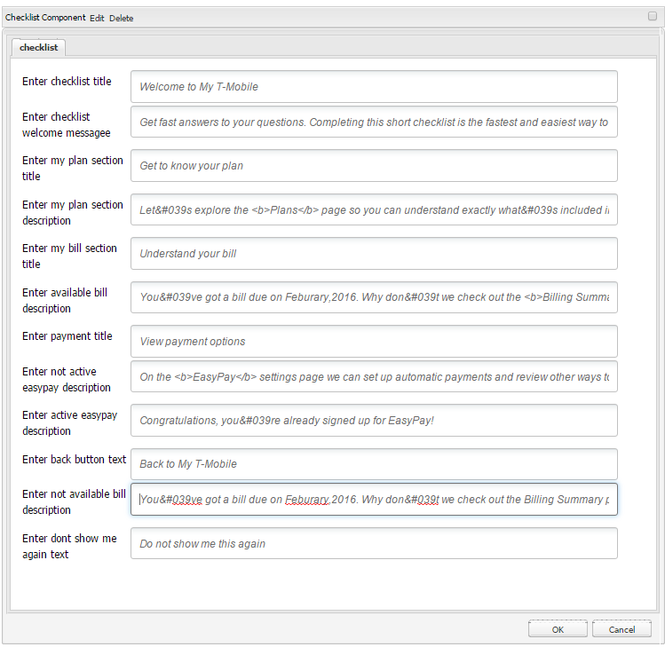

Edit the **following** field in component:

|  |  |
| --- | --- |
| Field | Value |
| Enter checklist title | Welcome to My T-Mobile, |
| Enter checklist welcome messagee | Get fast answers to your questions. Completing this short checklist is the fastest and easiest way to understand your new service |
| Enter my plan section title | Get to know your plan< |
| Enter my plan section description | Let&#039s explore the <b>Plans</b> page so you can understand exactly what&#039s included in your plan. |
| Enter my bill section title | Understand your bill |
| Enter available bill description | You&#039ve got a bill due on {1}. Why don&#039t we check out the <b>Billing Summary</b> page and review your charges. |
| Enter payment title | View payment options |
| Enter not active easypay description | On the <b>EasyPay settings</b> page we can set up automatic payments and review other ways to pay your bill. |
| Enter active easypay description | Congratulations, you&#039re already signed up for EasyPay! |
| Enter back button text | Back to My T-Mobile |
| Enter not available bill description | Your bill isn&#039t available yet, but it will be soon. You can view a walk-through of a typical T-Mobile bill by visiting the Understanding Your Bill page. |
| Enter dont show me aganin button text | Do not show me this again |

# US25112: [Go Big] Onboarding - (Mobile) Welcome/Checklist Modal

## Mobile Page Content Path:

* /content/mytmobile/en/mobile/home/jcr:content/contentarea/checklistPage
* url : /content/mytmobile/en/mobile/home.html

### Before snapshot:

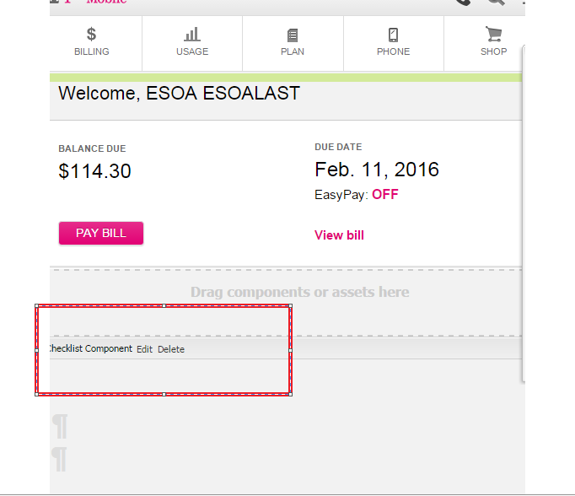

**After snapshot:**

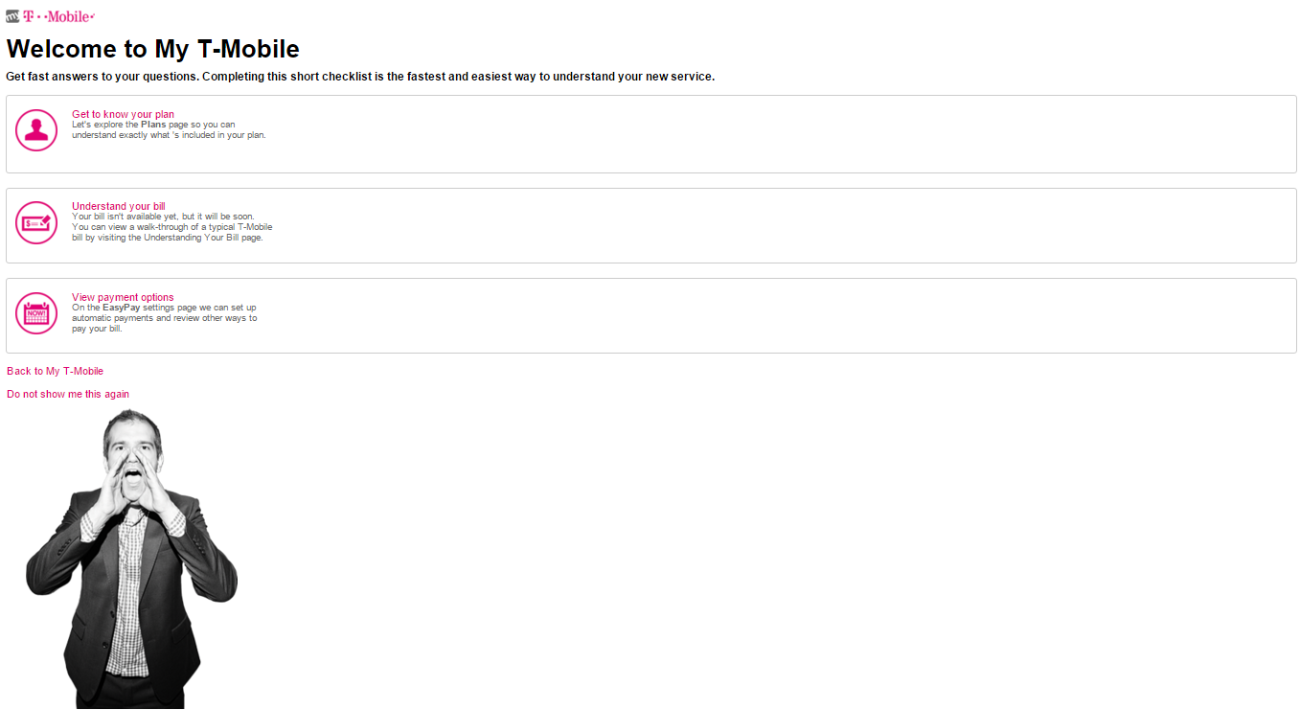

### Steps to author this update:

* Login into CQ author and go to site-admin console
* Navigate and click on “My T-Mobile | ” in site-navigation left pane under :
* Websites>mytmobile>English>Mobile>home.
* Double Click on the highlighted Page I, My T-Mobile | Home

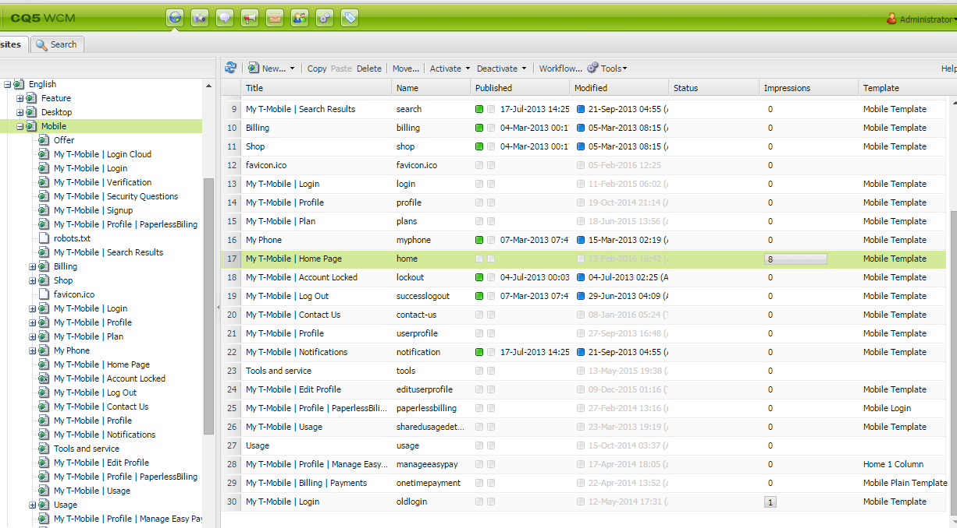

* Click on the edit option of the checklist component.

**Checklist:**

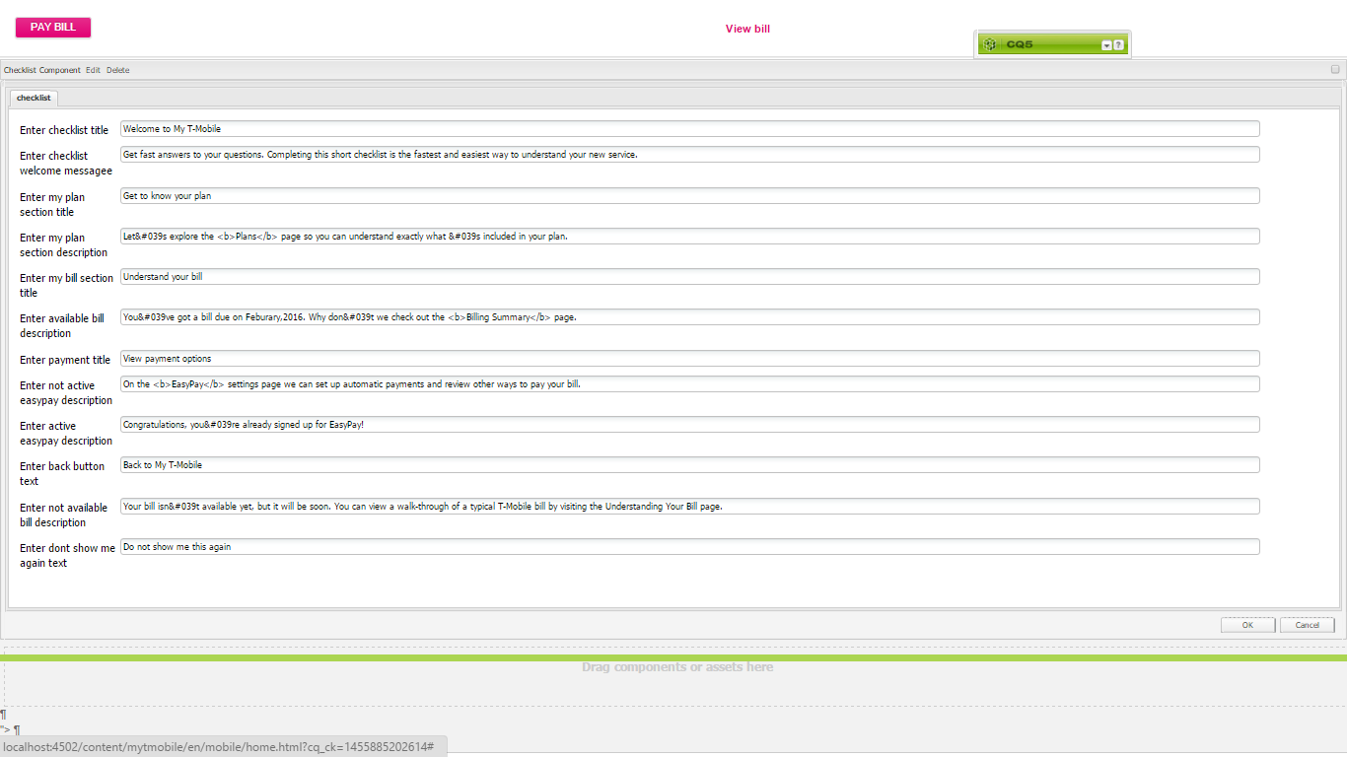

Edit the **following** field in component:

|  |  |
| --- | --- |
| Field | Value |
| Enter checklist title | Welcome to My T-Mobile, |
| Enter checklist welcome messagee | Get fast answers to your questions. Completing this short checklist is the fastest and easiest way to understand your new service. |
| Enter my plan section title | Get to know your plan |
| Enter my plan section description | Let&#039s explore the <b>Plans</b> page so you can understand exactly what &#039s included in your plan. |
| Enter my bill section title | Understand your bill |
| Enter available bill description | You&#039ve got a bill due on {1}. Why don&#039t we check out the <b>Billing Summary</b> page and review your charges. |
| Enter payment title | View payment options |
| Enter not active easypay description | On the <b>EasyPay settings</b> page we can set up automatic payments and review other ways to pay your bill. |
| Enter active easypay description | Congratulations, you &#039re already signed up for EasyPay! |
| Enter back button text | Back to My T-Mobile |
| Enter not available bill description | Your bill isn&#039t available yet, but it will be soon. You can view a walk-through of a typical T-Mobile bill by visiting the Understanding Your Bill page. |
| Enter dont show me aganin button text | Do not show me this again |

# US45081: [Go Big] Onboarding - (Desktop) Plan Tour - Plan Summary

## Desktop Page Content Path:

* /content/mytmobile/en/desktop/plans/jcr:content/header-parsys/tour
* Page URL : content/mytmobile/en/desktop/plans.html

### Steps to author this update:

* Login in to CQ author and go to siteadmin console.
* Navigate and click on “My T-Mobile | Plan” in site-navigation left pane under: Websites > mytmobile > English > Desktop > plans.
* Double click on "My T-Mobile | Plan".

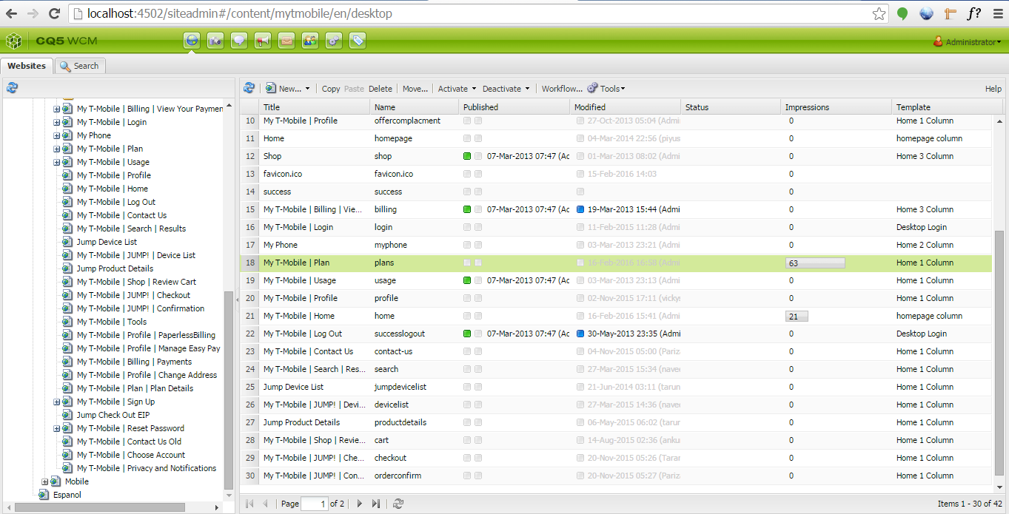

* Click on the edit option on tour component, a dialogue will be displayed.
* Edit the required fields and click ok.

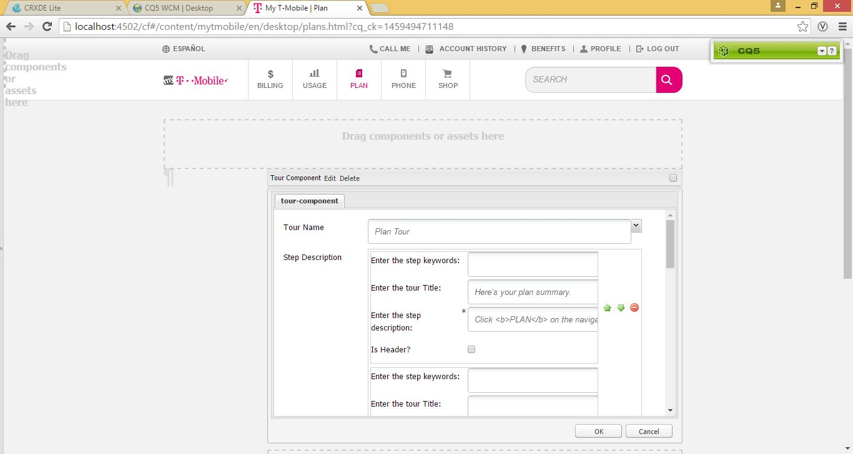

**Authoring tour component buttons:**

* Enter the required text in following fields.

|  |  |
| --- | --- |
| Field | Value |
| Enter begin button text | NEXT |
| Enter previous button text | PREVIOUS |
| Enter next button text | NEXT |
| Enter backtohub button text | Go to My Checklist |
| Enter done button text | DONE |

* Select tour name from the dropdown for selecting the respective tour.
* Below will be the selection in this case :-

|  |  |
| --- | --- |
| Field | Value |
| Tour Name | Plan Tour |

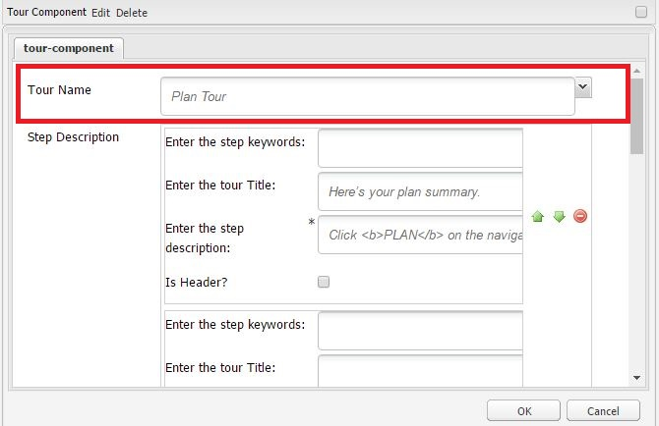

**Authoring Step description in tour dialogue:**

* Click on “Add Item” link under step description.
* Group with step keywords, tour title, description and Is Header checkbox will be added.
* Enter tour title and description as required.
* Step keywords should be left blank
* Is Header should be unchecked.
* Click “Add Item” link to add some more steps.

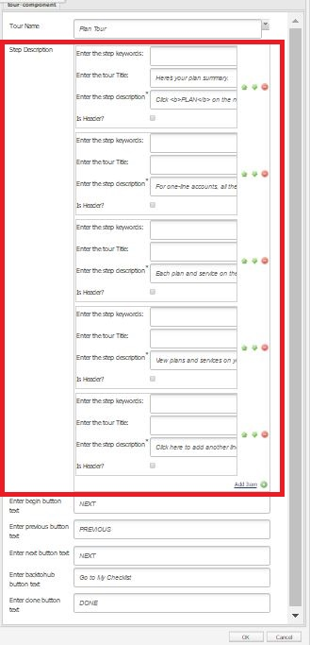

Below are the text copy has to authored for each user story

**US45081: [Go Big] Onboarding - (Desktop) Plan Tour - Plan Summary**

|  |  |
| --- | --- |
| Field | Value |
| Enter the step keywords: |  |
| Enter the tour Title: | Here’s your plan summary. |
| Enter the step description: | Click <b>PLAN</b> on the navigation menu to get here. |
| Is Header? |  |

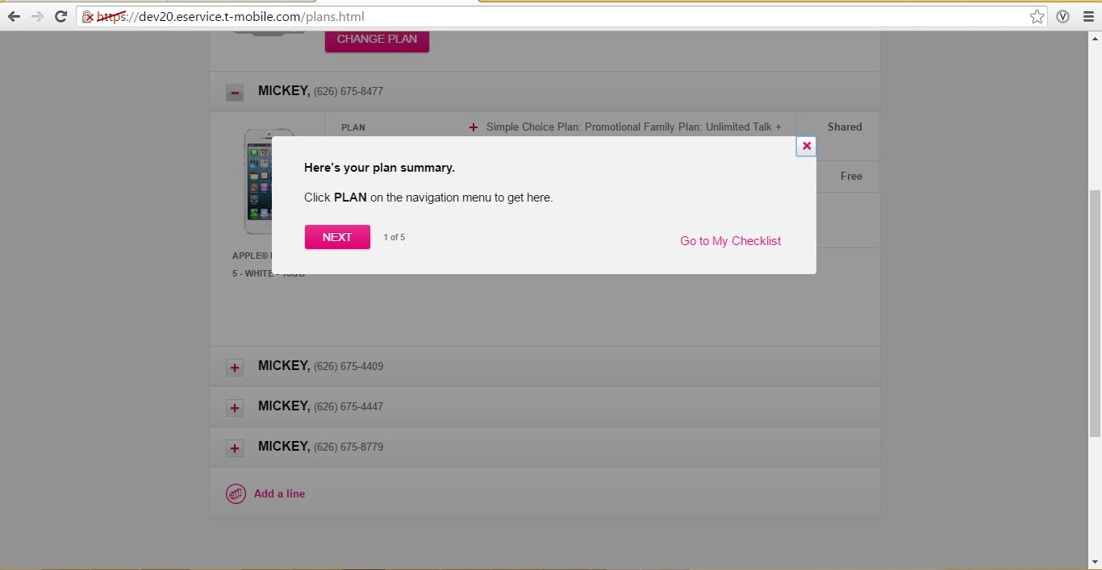

**US45085: [Go Big] Onboarding - (Desktop) Plan Tour - Account Information**

|  |  |
| --- | --- |
| Field | Value |
| Enter the step keywords: |  |
| Enter the tour Title: |  |
| Enter the step description: | For one-line accounts, all the plan and service information is bundled together. For accounts with multiple lines, the information is displayed on each line. |
| Is Header? |  |

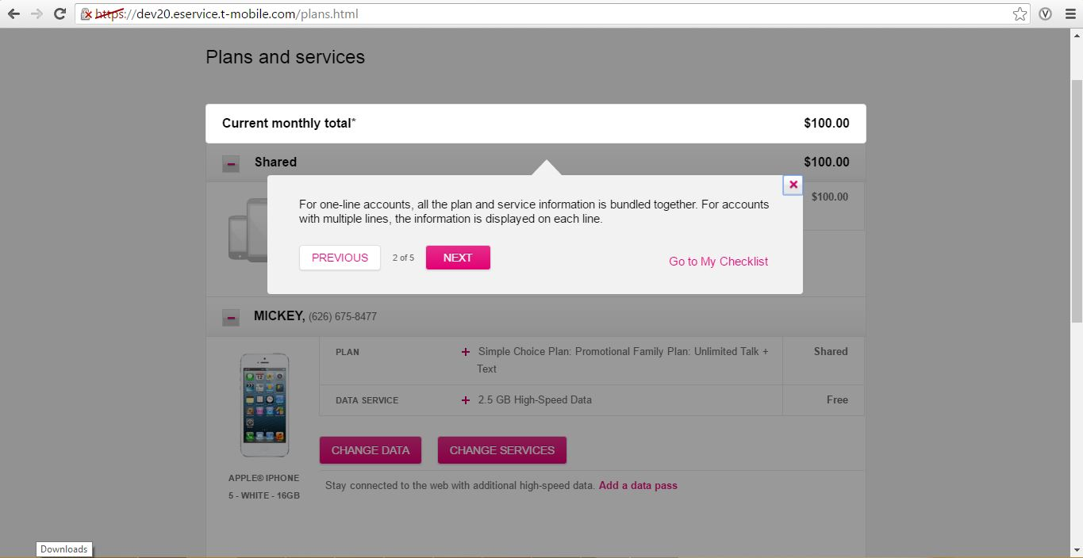

**US45087: [Go Big] Onboarding - (Desktop) Plan Tour - Plan Information**

|  |  |
| --- | --- |
| Field | Value |
| Enter the step keywords: |  |
| Enter the tour Title: |  |
| Enter the step description: | Each plan and service on the line is listed. Click on the line to see more information about the plan or service. |
| Is Header? |  |

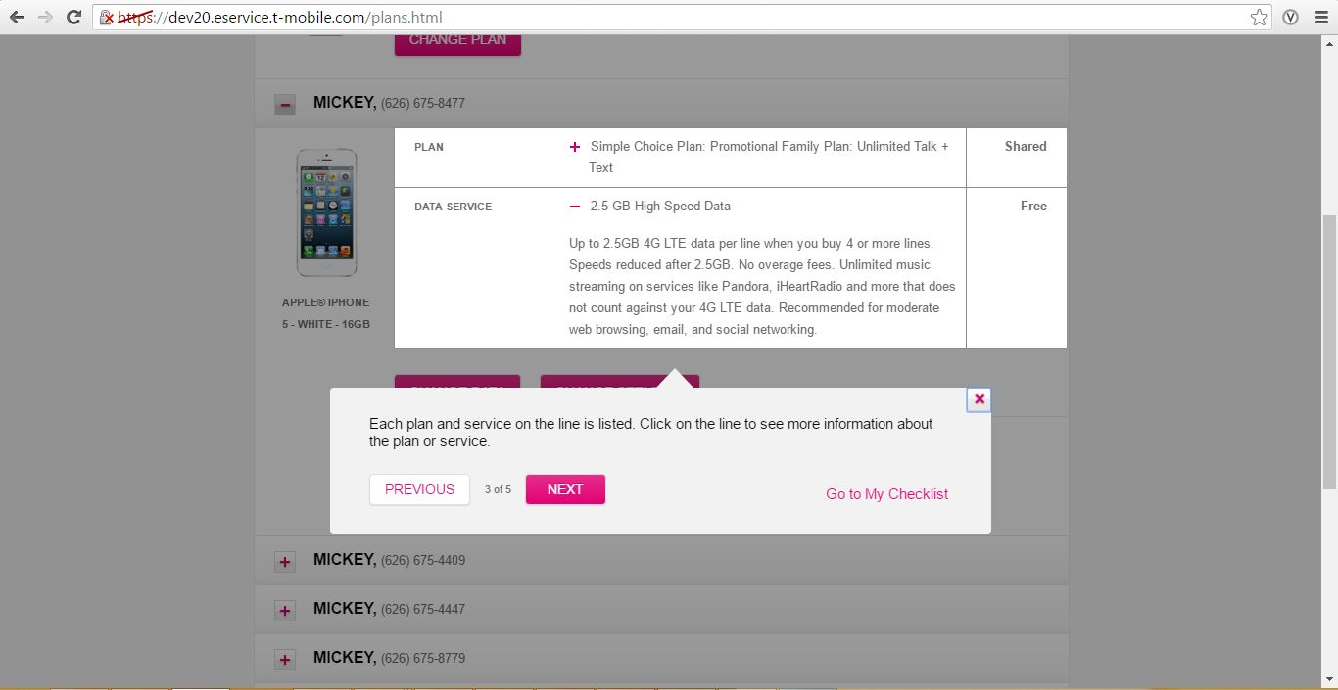

**US45114: [Go Big] Onboarding - (Desktop) Plan Tour - Change/View Plan, Data or Services**

|  |  |
| --- | --- |
| Field | Value |
| Enter the step keywords: |  |
| Enter the tour Title: |  |
| Enter the step description: | View plans and services on your account. You can update your monthly data plan or add a temporary data pass for short-term use. |
| Is Header? |  |

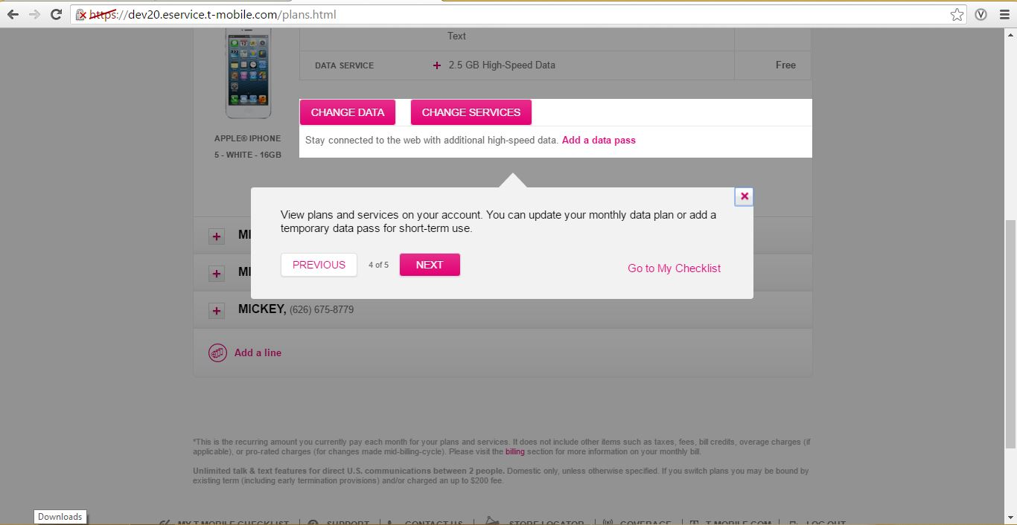

**US45117: [Go Big] Onboarding - (Desktop) Plan Tour - Add a Line**

|  |  |
| --- | --- |
| Field | Value |
| Enter the step keywords: |  |
| Enter the tour Title: |  |
| Enter the step description: | Click here to add another line to your account. |
| Is Header? |  |

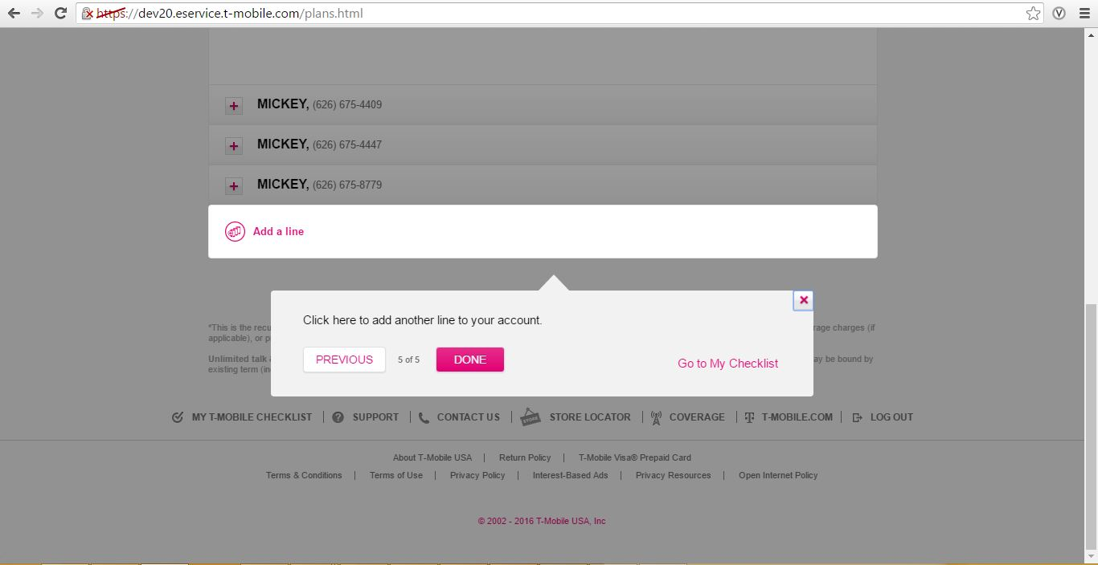

# US45084 [Go Big] Onboarding - (Mobile) Plan Tour - Plan Summary

## Mobile Page Content Path:

* /content/mytmobile/en/mobile/plans/jcr:content/contentarea/tour
* Page URL: content/mytmobile/en/mobile/plans.html

### Steps to author this update:

* Login in to CQ author and go to siteadmin console.
* Navigate and click on “My T-Mobile | Plan” in site-navigation left pane under: Websites > mytmobile > English > mobile > plans.
* Double click on "My T-Mobile | Plan".

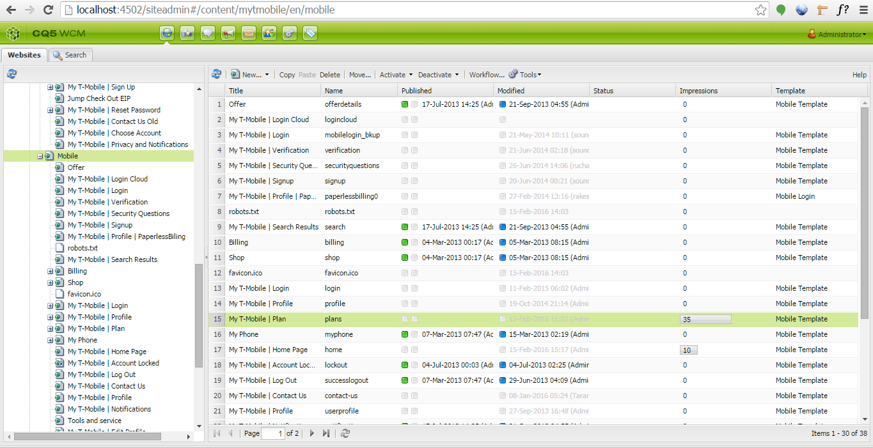

* Click on the edit option on tour component, a dialogue will be displayed.
* Edit the required fields and click on ok.

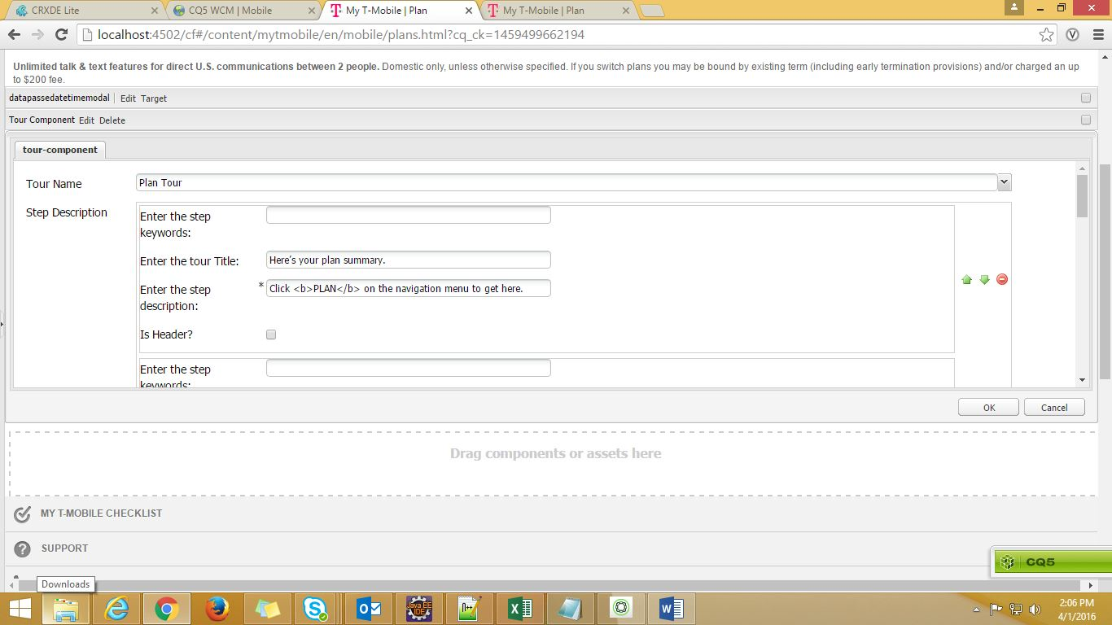

* Select tour name from the dropdown for selecting the respective tour.
* Below will be the selection in this case :-

|  |  |
| --- | --- |
| Field | Value |
| Tour Name | Plan Tour |

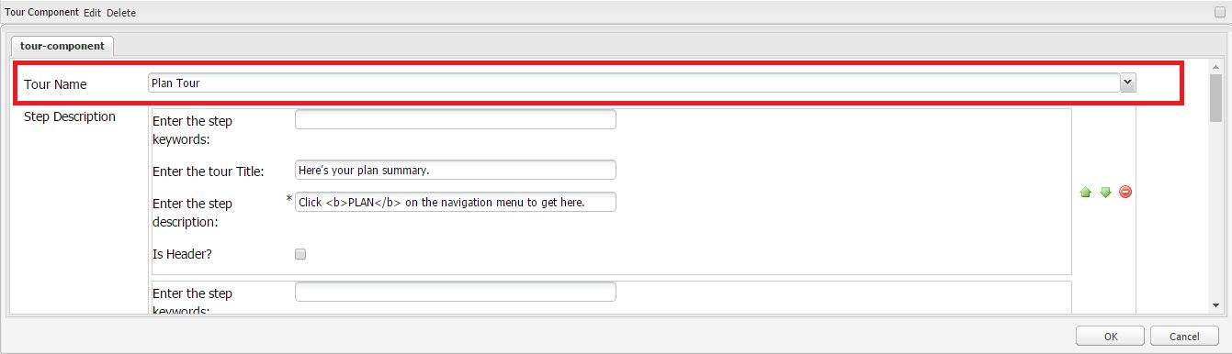

**Authoring tour component buttons:**

* Enter the required text in following fields.

|  |  |
| --- | --- |
| Field | Value |
| Enter begin button text | NEXT |
| Enter previous button text | PREVIOUS |
| Enter next button text | NEXT |
| Enter backtohub button text | Go to My Checklist |
| Enter done button text | DONE |

**Authoring Step description in tour dialogue:**

* Click on “Add Item” link under step description.
* Group with step keywords, tour title, description and Is Header checkbox will be added.
* Enter tour title and description as required.
* Step keywords should be left blank
* Is Header should be unchecked.
* Click “Add Item” link to add some more steps.

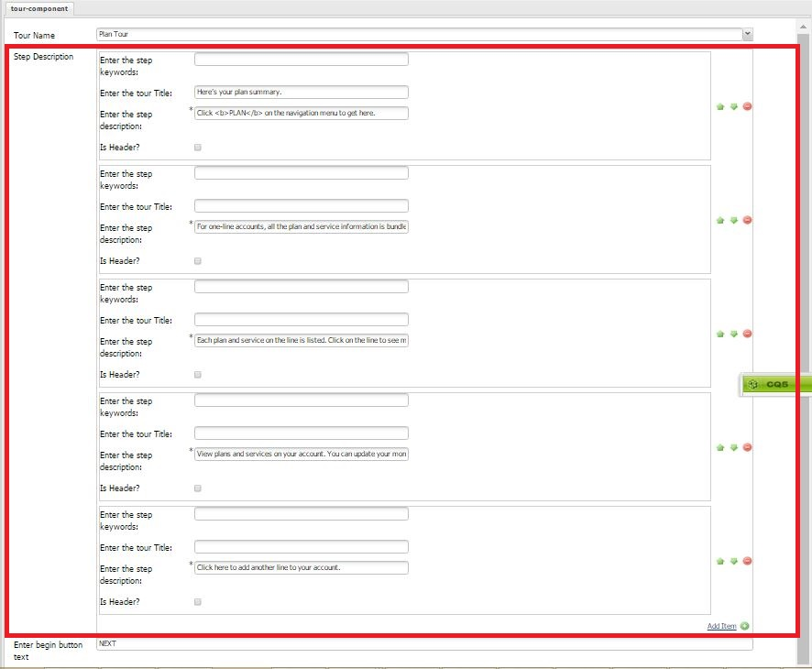

**Below are the text copy has to authored for each user story**

**US45084 [Go Big] Onboarding - (Mobile) Plan Tour - Plan Summary**

|  |  |
| --- | --- |
| Field | Value |
| Enter the step keywords: |  |
| Enter the tour Title: | Here’s your plan summary. |
| Enter the step description: | Click <b>PLAN</b> on the navigation menu to get here. |
| Is Header? |  |

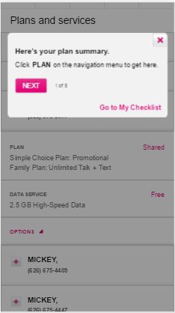

**US45086 [Go Big] Onboarding - (Mobile) Plan Tour - Account Information**

|  |  |
| --- | --- |
| Field | Value |
| Enter the step keywords: |  |
| Enter the tour Title: |  |
| Enter the step description: | For one-line accounts, all the plan and service information is bundled together. For accounts with multiple lines, the information is displayed on each line. |
| Is Header? |  |

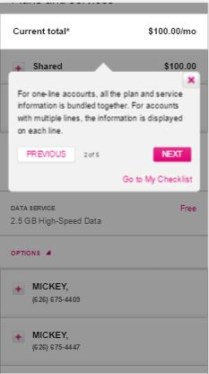

**US45094 [Go Big] Onboarding - (Mobile) Plan Tour - Plan Information**

|  |  |
| --- | --- |
| Field | Value |
| Enter the step keywords: |  |
| Enter the tour Title: |  |
| Enter the step description: | Each plan and service on the line is listed. Click on the line to see more information about the plan or service. |
| Is Header? |  |

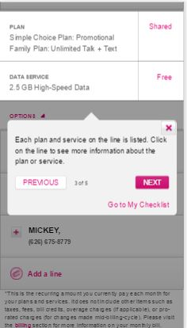

**US45116 [Go Big] Onboarding - (Mobile) Plan Tour - Change/View Plan, Data or Services**

|  |  |
| --- | --- |
| Field | Value |
| Enter the step keywords: |  |
| Enter the tour Title: |  |
| Enter the step description: | View plans and services on your account. You can update your monthly data plan or add a temporary data pass for short-term use. |
| Is Header? |  |

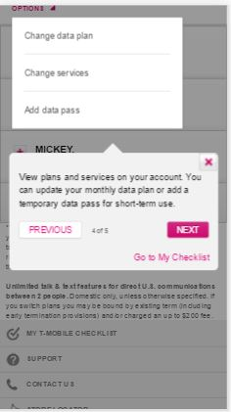

**US45122 [Go Big] Onboarding - (Mobile) Plan Tour - Add a Line**

|  |  |
| --- | --- |
| Field | Value |
| Enter the step keywords: |  |
| Enter the tour Title: |  |
| Enter the step description: | Click here to add another line to your account. |
| Is Header? |  |

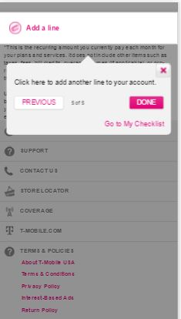

# US43644: [Go Big] Onboarding - (Desktop) EasyPay Tour - Sign up Modal

## Desktop Page Content Path:

* /content/mytmobile/en/desktop/billing/jcr:content/contentarea/easy pay tour
* Page URL: content/mytmobile/en/desktop/billing/manageasypay.html

### Steps to author this update:

* Login in to CQ author and go to siteadmin console.
* Navigate and click on “My T-Mobile | Billing | View Your Payment History” in site-navigation left pane under: Websites > mytmobile > English > Desktop >billing.
* Double click on "My T-Mobile | Billing | Manage Payments with EasyPay ".

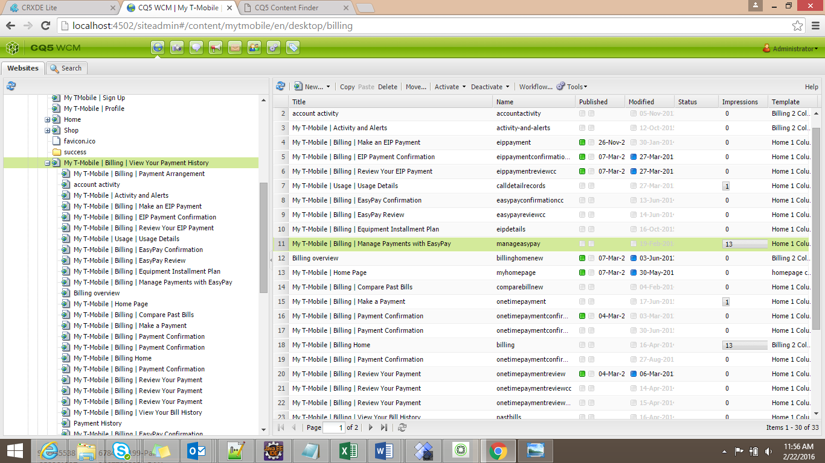

* Click on edit option on tour component, dialogue will be displayed.
* Edit the required fields and click on Ok.

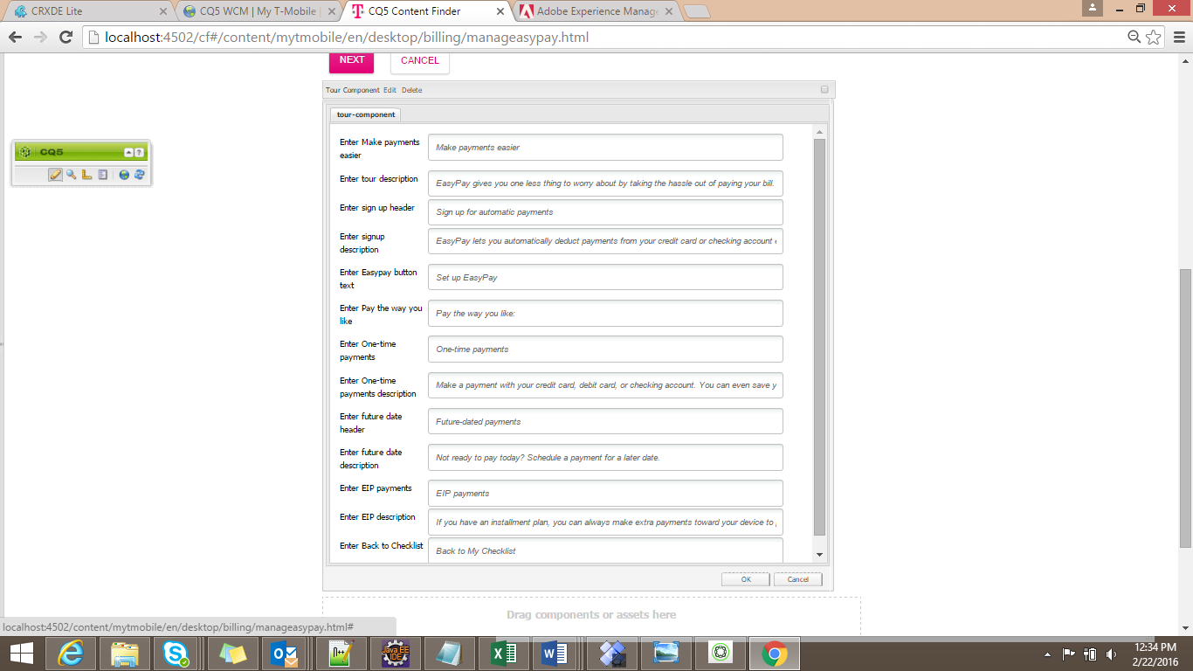

|  |  |
| --- | --- |
| Field | Value |
| Enter Make payments easier: | Make payments easier |
| Enter tour description: | EasyPay gives you one less thing to worry about by taking the hassle out of paying your bill. |
| Enter sign up header: | Sign up for automatic payments |
| Enter signup description: | EasyPay lets you automatically deduct payments from your credit card or checking account every month. Save stamps, save checks, and avoid late fees. |
| Enter Easypay button text: | SET UP EASYPAY |
| Enter Pay the way you like: | Pay the way you like: |
| Enter One-time payments: | One-time payments |
| Enter One-time payments description: | Make a payment with your credit card, debit card, or checking account. You can even save your card details for future use. |
| Enter future date header: | Future-dated payments |
| Enter future date description: | Not ready to pay today? Schedule a payment for a later date. |
| Enter EIP payments: | EIP payments |
| Enter EIP description: | If you have an installment plan, you can always make extra payments toward your device to pay it off early. |
| Enter Back to Checklist: | Back to My Checklist |

After click of Ok.

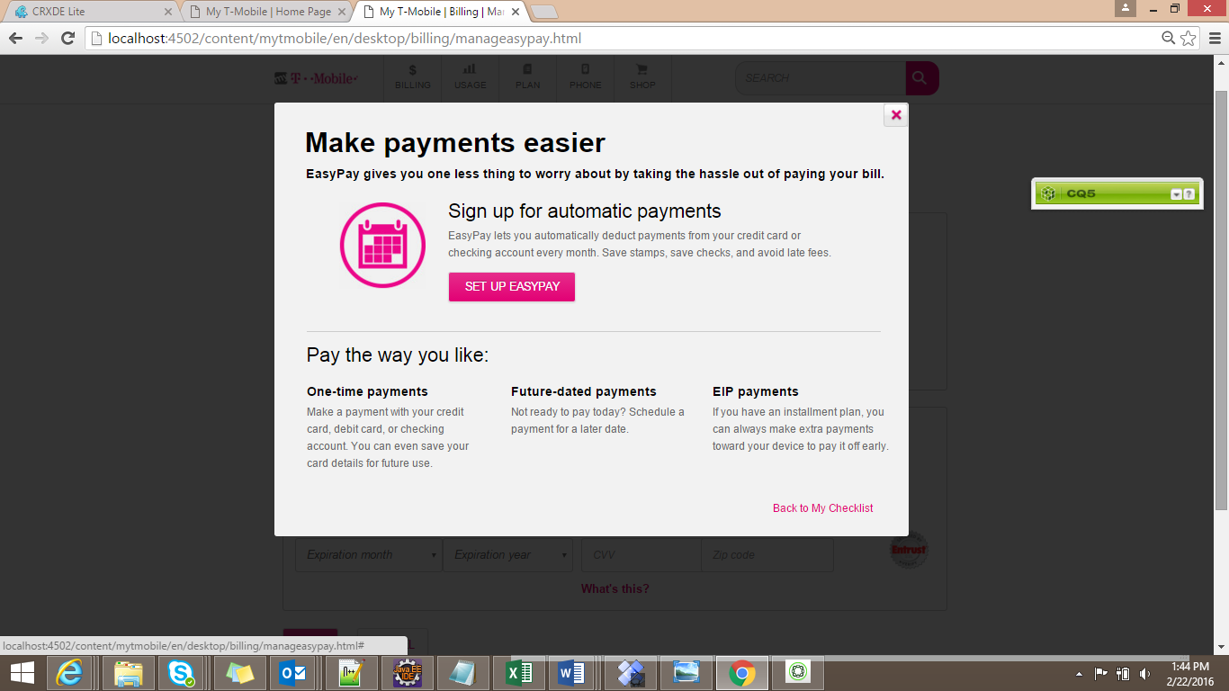

# US44941: [Go Big] Onboarding - (Mobile) EasyPay Tour - Sign up Modal

## Desktop Page Content Path:

* /content/mytmobile/en/mobile/billing/jcr:content/contentarea/easy pay tour
* Page URL: content/mytmobile/en/mobile/profile/editeasypay.html

### Steps to author this update:

* Login in to CQ author and go to siteadmin console.
* Navigate and click on “My T-Mobile | Profile” in site-navigation left pane under: Websites > mytmobile > English > Mobile >Profile.
* Double click on "My T-Mobile | Profile | Edit EasyPay with EasyPay ".

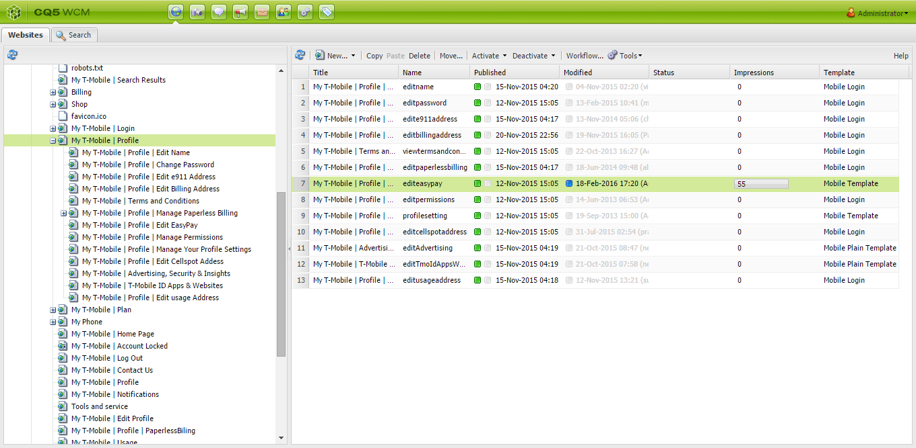

* Click on edit option on tour component, dialogue will be displayed.
* Edit the required fields and click on Ok.



|  |  |
| --- | --- |
| Field | Value |
| Enter Make payments easier: | Make payments easier |
| Enter tour description: | EasyPay gives you one less thing to worry about by taking the hassle out of paying your bill. |
| Enter sign up header: | Sign up for automatic payments |
| Enter signup description: | EasyPay lets you automatically deduct payments from your credit card or checking account every month. Save stamps, save checks, and avoid late fees. |
| Enter Easypay button text: | SET UP EASYPAY |
| Enter Pay the way you like: | Pay the way you like: |
| Enter One-time payments: | One-time payments |
| Enter One-time payments description: | Make a payment with your credit card, debit card, or checking account. You can even save your card details for future use. |
| Enter future date header: | Future-dated payments |
| Enter future date description: | Not ready to pay today? Schedule a payment for a later date. |
| Enter EIP payments: | EIP payments |
| Enter EIP description: | If you have an installment plan, you can always make extra payments toward your device to pay it off early. |
| Enter Back to Checklist: | Back to My Checklist |

After click of Ok.

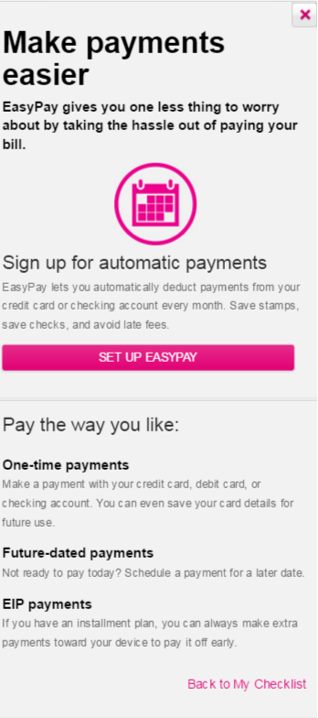

# US39701: [Go Big] Onboarding - (Desktop) Bill Tour - Beginning of Tour

## Desktop Page Content Path:

* /content/mytmobile/en/desktop/billing/summary/jcr:content/contentarea/tour
* Page URL : /content/mytmobile/en/desktop/billing/summary.html

### Steps to author this update:

* Login in to CQ author and go to siteadmin console.
* Navigate and click on “My T-Mobile | Billing | View Your Payment” in site-navigation left pane under: Websites > mytmobile > English > Desktop >
* Double click on "My T-Mobile | Bill Summary".

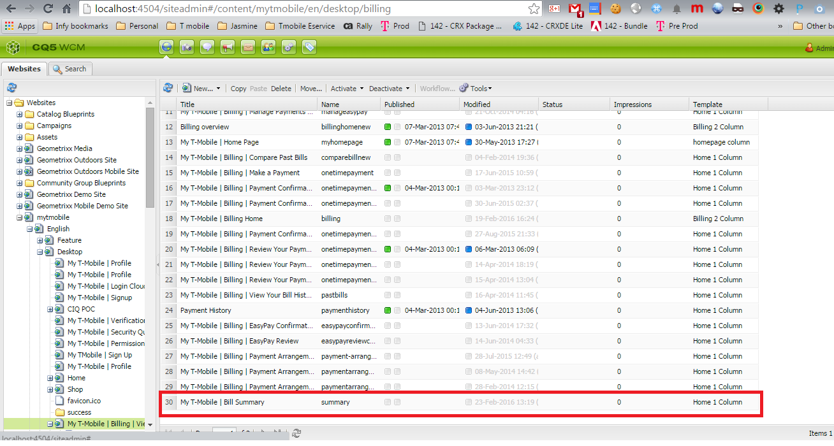

* Click on the edit option on tour component, a dialogue will be displayed.
* Edit the required fields and click ok.

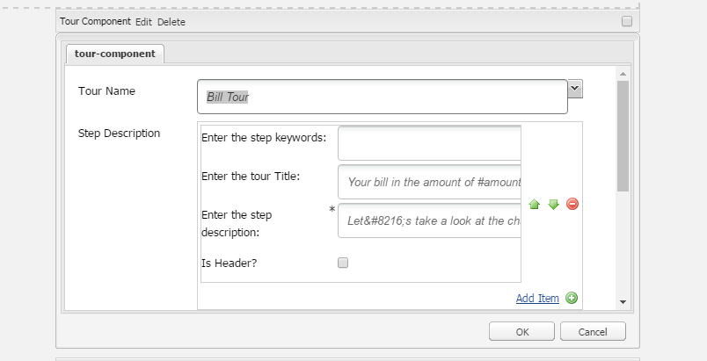

* Select tour name from the dropdown for selecting the respective tour.
* Below will be the selection in this case :-

|  |  |
| --- | --- |
| Field | Value |
| Tour Name | Bill Tour |

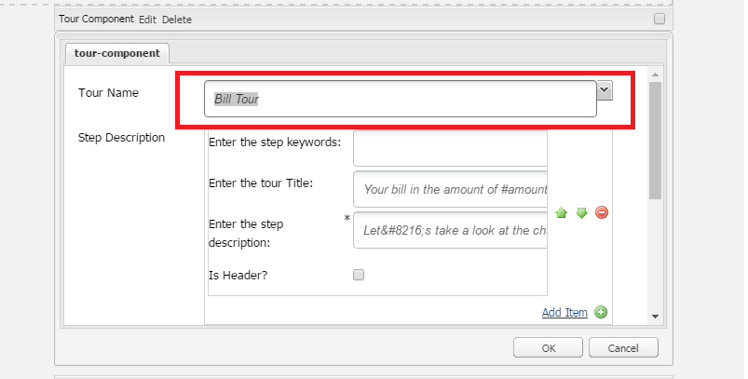

**Authoring tour component buttons:**

* Enter the required text in following fields.

|  |  |
| --- | --- |
| Field | Value |
| Enter begin button text | NEXT |
| Enter previous button text | PREVIOUS |
| Enter next button text | NEXT |
| Enter backtohub button text | Go to My Checklist |
| Enter done button text | DONE |

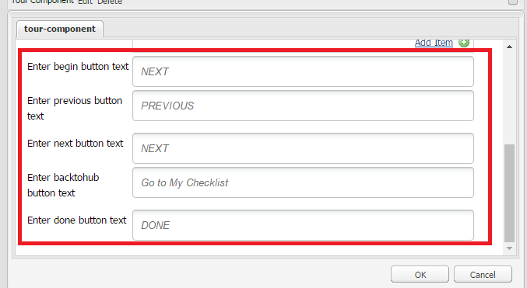

**Authoring Step description in tour dialogue:**

* Click on “Add Item” link under step description.
* Group with tour title and description will be added.
* Enter tour title and description as required.
* Step keywords should be left blank.
* Is Header should be unchecked.

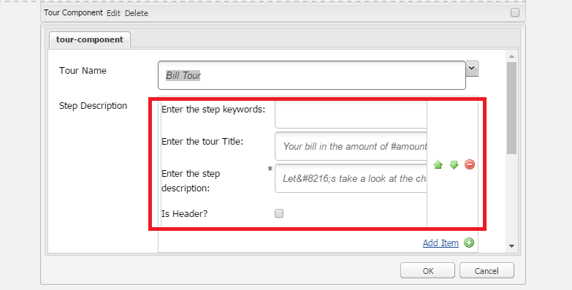

Below are the text copy has to authored for each user story

**US39701: [Go Big] Onboarding - (Desktop) Bill Tour – Beginning of Tour**

|  |  |
| --- | --- |
| Field | Value |
| Enter the step keyword: |  |
| Enter the tour Title: | Your bill in the amount of #amount is due on #date. |
| Enter the step description: | Let&#8216;s take a look at the charges on this bill. |
| Is Header? |  |

**Note: #amount and #date will be replaced by user data at runtime.**

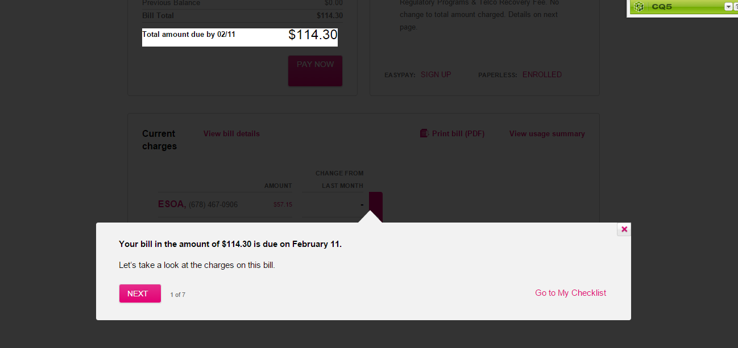

# US39764: [Continued] [Go Big] Onboarding - (Desktop) Bill Tour - Account/Line Selector Step #1 (Multi-line only)

## Desktop Page Content Path:

* /content/mytmobile/en/desktop/billing/details/jcr:content/contentarea/tour
* Page URL : /content/mytmobile/en/desktop/billing/details.html.

### Steps to author this update:

* Login in to CQ author and go to siteadmin console.
* Navigate and click on “My T-Mobile | Billing | View Your Payment” in site-navigation left pane under: Websites > mytmobile > English > Desktop >
* Double click on "My T-Mobile | Billing|View Bill Details".

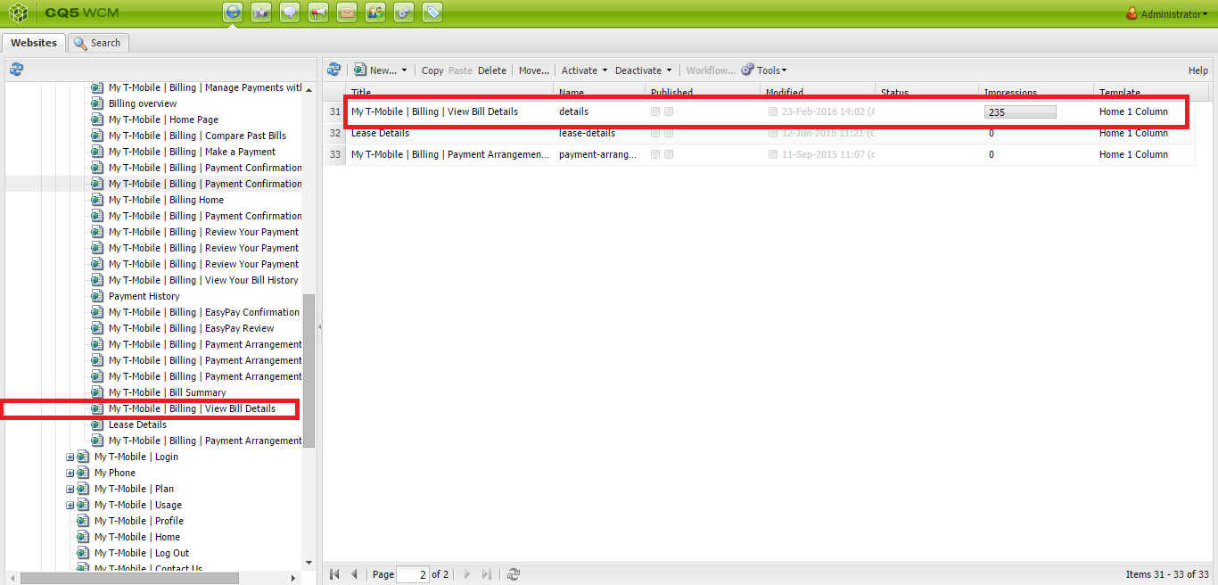

* Click on the edit option on tour component, a dialogue will be displayed.
* Select tour name from the dropdown for selecting the respective tour.
* Below will be the selection in this case :-

|  |  |
| --- | --- |
| Field | Value |
| Tour Name | Bill Tour |

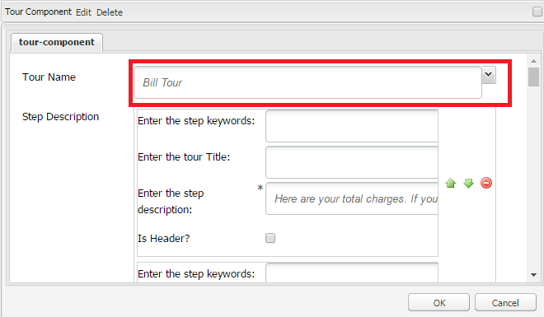

**Authoring tour component buttons:**

* Enter the required text in following fields.

|  |  |
| --- | --- |
| Field | Value |
| Enter begin button text | NEXT |
| Enter previous button text | PREVIOUS |
| Enter next button text | NEXT |
| Enter backtohub button text | Go to My Checklist |
| Enter done button text | DONE |

**Authoring Step description in tour dialogue:**

* Click on “Add Item” link under step description.
* Group with tour title and description will be added.
* Enter tour title and description as required.
* Click “Add Item” link to add some more steps.
* Step keywords should be left blank.
* Is Header should be unchecked.
* Edit the required fields and click ok.

Below are the text copy has to authored for each user story

US39764**: [Continued] [Go Big] Onboarding - (Desktop) Bill Tour - Account/Line Selector Step #1 (Multi-line only)**

|  |  |
| --- | --- |
| Field | Value |
| Enter the step keyword: |  |
| Enter the tour Title: |  |
| Enter the step description: | Here are your total charges. If you click the arrows, you can view line-specific charges. |
| Is Header? |  |

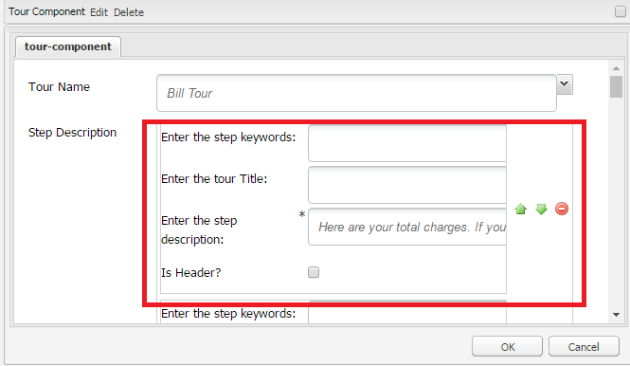

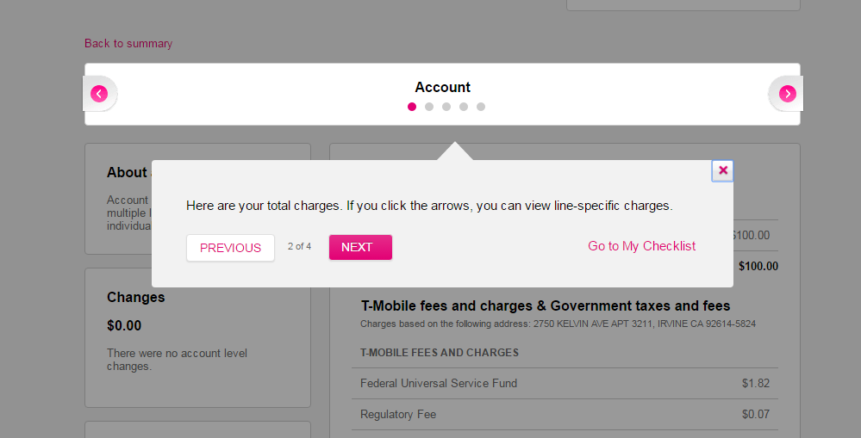

# US41486: [Continued] [Go Big] Onboarding - (Desktop) Bill Tour - Account/Line Selector Step #2 (Multi-line only)

## Desktop Page Content Path:

* /content/mytmobile/en/desktop/billing/details/jcr:content/contentarea/tour
* Page URL : /content/mytmobile/en/desktop/billing/details.html

### Steps to author this update:

* Login in to CQ author and go to siteadmin console.
* Navigate and click on “My T-Mobile | Billing | View Your Payment” in site-navigation left pane under: Websites > mytmobile > English > Desktop >
* Double click on "My T-Mobile | Billing|View Bill Details".



* Click on the edit option on tour component, a dialogue will be displayed.
* Edit the required fields and click ok.

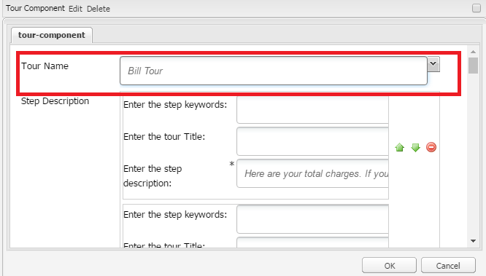

• Select tour name from the dropdown for selecting the respective tour.

• Below will be the selection in this case:

|  |  |
| --- | --- |
| Field | Value |
| Tour Name | Bill Tour |

**Authoring tour component buttons:**

* Enter the required text in following fields.

|  |  |
| --- | --- |
| Field | Value |
| Enter begin button text | NEXT |
| Enter previous button text | PREVIOUS |
| Enter next button text | NEXT |
| Enter backtohub button text | Go to My Checklist |
| Enter done button text | DONE |

**Authoring Step description in tour dialogue:**

* Click on “Add Item” link under step description.
* Group with tour title and description will be added.
* Enter tour title and description as required.
* Step keywords should be left blank.
* Is Header should be unchecked.
* Click “Add Item” link to add some more steps.

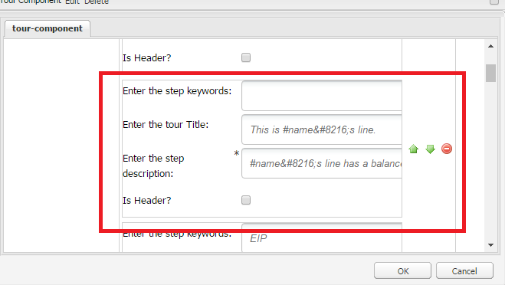

US41486**: [Continued] [Go Big] Onboarding - (Desktop) Bill Tour - Account/Line Selector Step #2 (Multi-line only)**

|  |  |
| --- | --- |
| Field | Value |
| Enter the step keywords: |  |
| Enter the tour Title: | This is #name&#8216;s line. |
| Enter the step description: | #name&#8216;s line has a balance of #balance. Let&#8216;s review the charges for #name&#8216;s line on the Billing Details page. |
| Is Header? |  |

**Note: #name and #balance will be replaced with user data on runtime.**

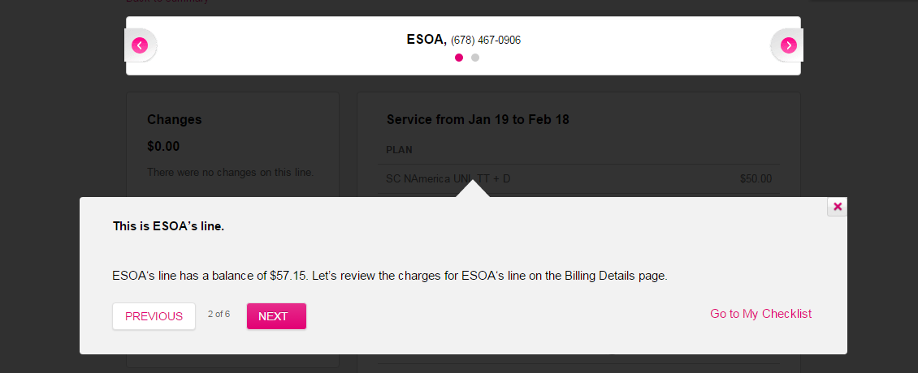

# US42941: [Go Big] Onboarding - (Mobile) Bill Tour - Beginning of Tour

## Mobile Page Content Path:

* /content/mytmobile/en/mobile/billing/summary/jcr:content/contentarea/tour
* Page URL : /content/mytmobile/en/mobile/billing/summary.html

### Steps to author this update:

* Login in to CQ author and go to siteadmin console.
* Navigate and click on “Billing” in site-navigation left pane under: Websites > mytmobile > English > Mobile
* Double click on "My T-Mobile | Bill Summary".

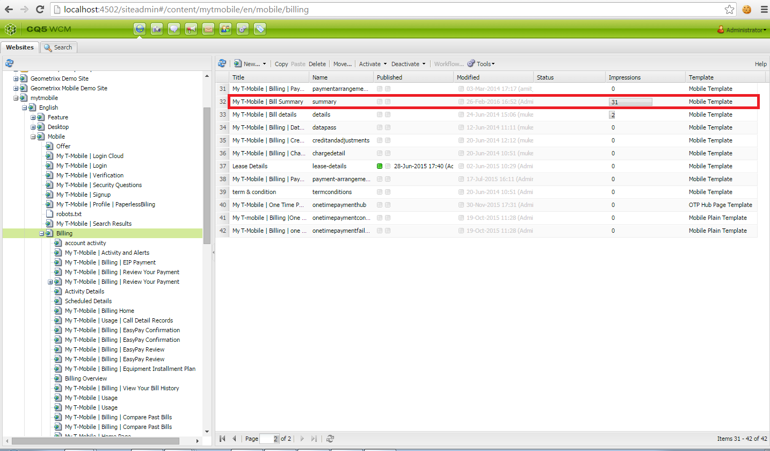

* Click on the edit option on tour component, a dialogue will be displayed.
* Edit the required fields and click ok.
* Select tour name from the dropdown for selecting the respective tour.
* Below will be the selection in this case :-

|  |  |
| --- | --- |
| Field | Value |
| Tour Name | Bill Tour |

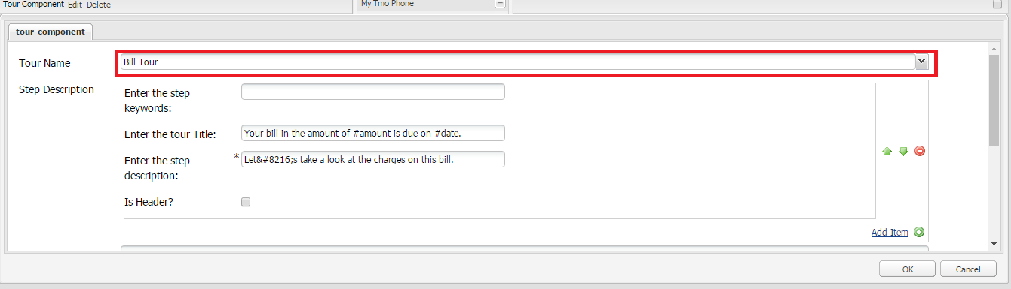

**Authoring tour component buttons:**

* Enter the required text in following fields.

|  |  |
| --- | --- |
| Field | Value |
| Enter begin button text | NEXT |
| Enter previous button text | PREVIOUS |
| Enter next button text | NEXT |
| Enter backtohub button text | Go to My Checklist |
| Enter done button text | DONE |

**Authoring Step description in tour dialogue:**

* Click on “Add Item” link under step description.
* Group with tour title and description will be added.
* Enter tour title and description as required.
* Step keywords should be left blank.
* Is Header should be unchecked.
* Below are the text copy that has to be authored for the user story

|  |  |
| --- | --- |
| Field | Value |
| Enter the step keywords: |  |
| Enter the tour Title: | Your bill in the amount of #amount is due on #date. |
| Enter the step description: | Let&#8216;s take a look at the charges on this bill. |
| Is Header? |  |

**Note: #amount and #date will be replaced by user data at runtime.**

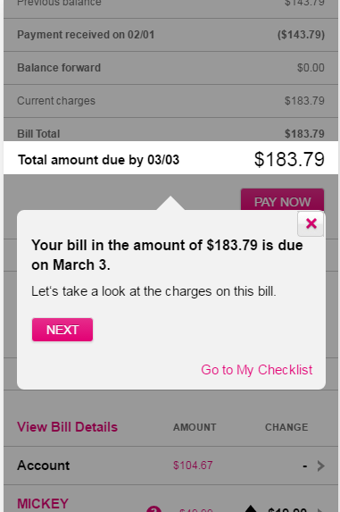

# US43202: [Go Big] Onboarding - (Mobile) Bill Tour - Account/Line Selector Step #1 (Multi-line only)

## Mobile Page Content Path:

* /content/mytmobile/en/mobile/billing/details/jcr:content/contentarea/tour
* Page URL : /content/mytmobile/en/mobile/billing/details.html

### Steps to author this update:

* Login in to CQ author and go to siteadmin console.
* Navigate and click on “Billing” in site-navigation left pane under: Websites > mytmobile > English > Mobile
* Double click on " My T-Mobile | Bill details".

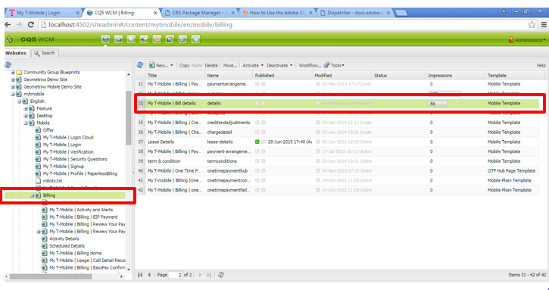

* Click on the edit option on tour component, a dialogue will be displayed.
* Edit the required fields and click ok.
* Select tour name from the dropdown for selecting the respective tour.
* Below will be the selection in this case :-

|  |  |
| --- | --- |
| Field | Value |
| Tour Name | Bill Tour |



**Authoring tour component buttons:**

* Enter the required text in following fields.

|  |  |
| --- | --- |
| Field | Value |
| Enter begin button text | NEXT |
| Enter previous button text | PREVIOUS |
| Enter next button text | NEXT |
| Enter backtohub button text | Go to My Checklist |
| Enter done button text | DONE |

**Authoring Step description in tour dialogue:**

* Click on “Add Item” link under step description.
* Group with tour title and description will be added.
* Enter tour title and description as required.
* Click “Add Item” link to add some more steps.
* Step keywords should be left blank.
* Is Header should be unchecked.
* Below are the text copy that has to be authored for user story

|  |  |
| --- | --- |
| Field | Value |
| Enter the step keywords: |  |
| Enter the tour Title: |  |
| Enter the step description: | Here are your total charges. If you click the arrows, you can view line-specific charges. |
| Is Header? |  |



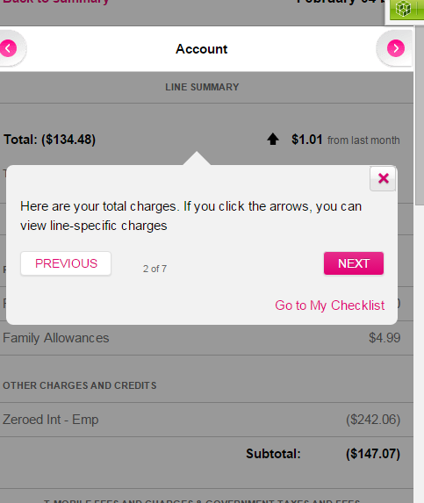

# US43204: [Go Big] Onboarding - (Mobile) Bill Tour - Account/Line Selector Step #2 (Multi-line only)

## Mobile Page Content Path:

* /content/mytmobile/en/mobile/billing/details/jcr:content/contentarea/tour
* Page URL : /content/mytmobile/en/mobile/billing/details.html

### Steps to author this update:

* Login in to CQ author and go to siteadmin console.
* Navigate and click on “Billing” in site-navigation left pane under: Websites > mytmobile > English > Mobile
* Double click on " My T-Mobile | Bill details".



* Click on the edit option on tour component, a dialogue will be displayed.
* Edit the required fields and click ok.

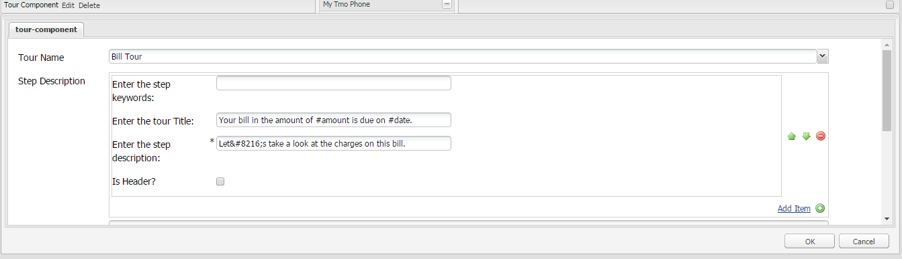

• Select tour name from the dropdown for selecting the respective tour.

• Below will be the selection in this case :-

|  |  |
| --- | --- |
| Field | Value |
| Tour Name | Bill Tour |



**Authoring tour component buttons:**

* Enter the required text in following fields.

|  |  |
| --- | --- |
| Field | Value |
| Enter begin button text | NEXT |
| Enter previous button text | PREVIOUS |
| Enter next button text | NEXT |
| Enter backtohub button text | Go to My Checklist |
| Enter done button text | DONE |

**Authoring Step description in tour dialogue:**

* Click on “Add Item” link under step description.
* Group with tour title and description will be added.
* Enter tour title and description as required.
* Step keywords should be left blank.
* Is Header should be unchecked.
* Click “Add Item” link to add some more steps.
* Below are the text copy that has to be authored for user story.

|  |  |
| --- | --- |
| Field | Value |
| Enter the step keyword: |  |
| Enter the tour Title: | This is #name&#8216;s line. |
| Enter the step description: | #name&#8216;s line has a balance of #balance. Let&#8216;s review the charges for #name&#8216;s line on the Billing Details page. |
| Is Header? |  |

* **Note: #name and #balance will be replaced with user data on runtime.**



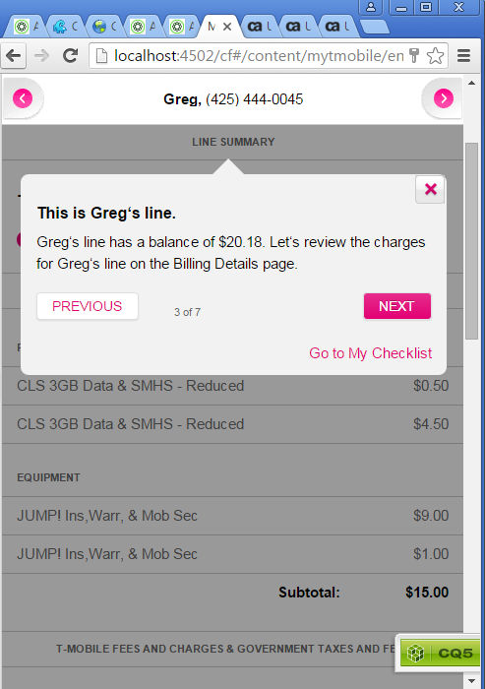

# US44944: [Go Big] Onboarding - (Desktop) Bill Tour - Highlight Line Items

### Desktop Page Content Path:

* /content/mytmobile/en/desktop/billing/details/jcr:content/contentarea/tour
* Page URL : /content/mytmobile/en/desktop/billing/details.html.

### Steps to author this update:

* Login in to CQ author and go to siteadmin console.
* Navigate and click on “My T-Mobile | Billing | View Your Payment” in site-navigation left pane under: Websites > mytmobile > English > Desktop >
* Double click on "My T-Mobile | Billing|View Bill Details".



* Click on the edit option on tour component, a dialogue will be displayed.
* Select tour name from the dropdown for selecting the respective tour.
* Below will be the selection in this case :-

|  |  |
| --- | --- |
| Field | Value |
| Tour Name | Bill Tour |



**Authoring tour component buttons:**

* Enter the required text in following fields.

|  |  |
| --- | --- |
| Field | Value |
| Enter begin button text | NEXT |
| Enter previous button text | PREVIOUS |
| Enter next button text | NEXT |
| Enter backtohub button text | Go to My Checklist |
| Enter done button text | DONE |

**Authoring Step description in tour dialogue:**

* Click on “Add Item” link under step description.
* Group with tour title and description will be added.
* Enter step keywords, tour title and description as required.
* Is Header should be checked if the keyword is a header keyword.
* Click “Add Item” link to add some more steps.
* Edit the required fields and click ok.

Below are the example of text copy has to be authored for this story

**US44944: [Go Big] Onboarding - (Desktop) Bill Tour - Highlight Line Items**

**Example of a header keyword:**

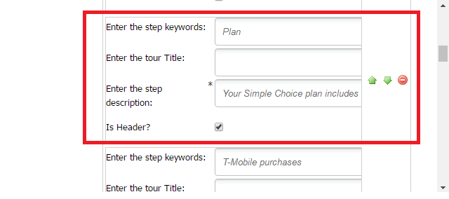

|  |  |
| --- | --- |
| Field | Value |
| Enter the step keyword: | Plan |
| Enter the tour Title: |  |
| Enter the step description: | Your Simple Choice plan includes unlimited talk, text, and data on our network, including the specified amount of high-speed data, with no data overages, plus Data Stash. |
| Is Header | Checked |

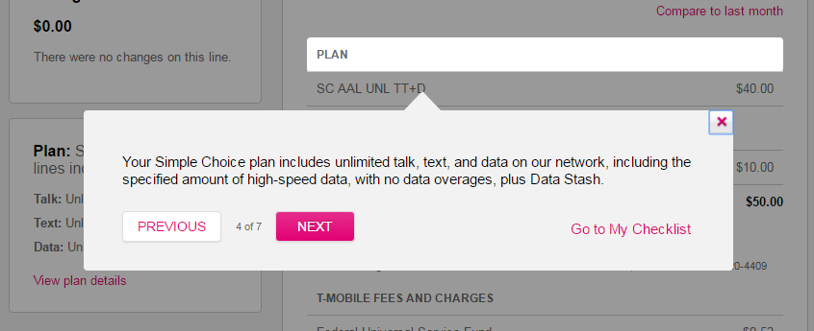

**Example of line item keyword:**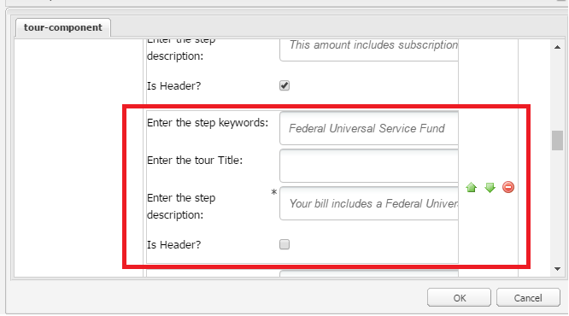

|  |  |
| --- | --- |
| Field | Value |
| Enter the step keyword: | Federal Universal Service Fund |
| Enter the tour Title: |  |
| Enter the step description: | Your bill includes a Federal Universal Service Fund charge to support access to telecommunication services for certain qualifying consumers. This charge is applied to all customer accounts. |
| Is Header | unchecked |

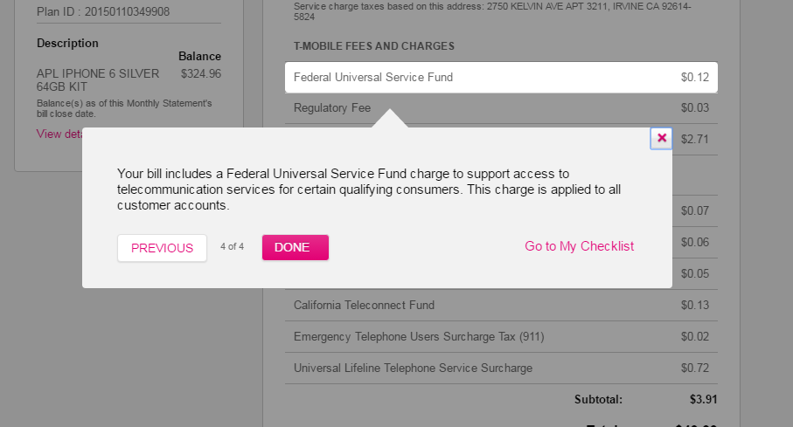

A few more examples of line items keywords

Is Header will be unchecked for all the below

|  |  |
| --- | --- |
| Field | Value |
| Enter the step keyword: | JUMP! Ins,Warr, &amp; Mob Sec |
| Enter the tour Title: |  |
| Enter the step description: | Your line includes JUMP!, so you can upgrade your device after you’ve paid 50% of its price. |
| Is Header? | unchecked |
| Enter the step keyword: | Federal Universal Service Fund |
| Enter the tour Title: |  |
| Enter the step description: | Your bill includes a Federal Universal Service Fund charge to support access to telecommunication services for certain qualifying consumers. This charge is applied to all customer accounts. |
| Is Header? | unchecked |
| Enter the step keyword: | Utility Use |
| Enter the tour Title: |  |
| Enter the step description: | Your bill includes a Utility fee to supports your state&#39;s Public Utilities Commission, the governing body that regulates wireless rates, or your local authorities. This tax is required by local law and not imposed by T-Mobile. |
| Is Header? | unchecked |
| Enter the step keyword: | SCORE! |
| Enter the tour Title: |  |
| Enter the step description: | Your bill includes a monthly charge for a no-extra cost upgrade to a basic 4G smartphone after 6 months. Or, after 12 months at that rate, you&#39;ll get discounts on all new phones. |
| Is Header? | unchecked |
| Enter the step keyword: | Premium Voicemail |
| Enter the tour Title: |  |
| Enter the step description: | This fee covers the Voicemail to Text feature, which converts voicemails into text messages or emails, then sends them to your T-Mobile® Visual Voicemail inbox. |
| Is Header? | unchecked |
| Enter the step keyword: | T-Mobile CallerTunes Basic |
| Enter the tour Title: |  |
| Enter the step description: | This charge covers CallerTunes®, which lets you play incoming callers a special announcement or song instead of a ringtone they&#39;d normally hear. |
| Is Header? | unchecked |

# US44945: [Continued] [Go Big] Onboarding - (Mobile) Bill Tour - Highlight Line Items

## Mobile Page Content Path:

* /content/mytmobile/en/mobile/billing/details/jcr:content/contentarea/tour
* Page URL : /content/mytmobile/en/mobile/billing/details.html

### Steps to author this update:

* Login in to CQ author and go to siteadmin console.
* Navigate and click on “Billing” in site-navigation left pane under: Websites > mytmobile > English > Mobile
* Double click on " My T-Mobile | Bill details".



* Click on the edit option on tour component, a dialogue will be displayed.
* Edit the required fields and click ok.
* Select tour name from the dropdown for selecting the respective tour.
* Below will be the selection in this case :-

|  |  |
| --- | --- |
| Field | Value |
| Tour Name | Bill Tour |



**Authoring tour component buttons:**

* Enter the required text in following fields.

|  |  |
| --- | --- |
| Field | Value |
| Enter begin button text | NEXT |
| Enter previous button text | PREVIOUS |
| Enter next button text | NEXT |
| Enter backtohub button text | Go to My Checklist |
| Enter done button text | DONE |

**Authoring Step description in tour dialogue:**

* Click on “Add Item” link under step description.
* Group with tour title and description will be added.
* Enter step keywords, tour title and description as required.
* Is Header should be checked if the keyword is a header keyword.
* Click “Add Item” link to add some more steps.

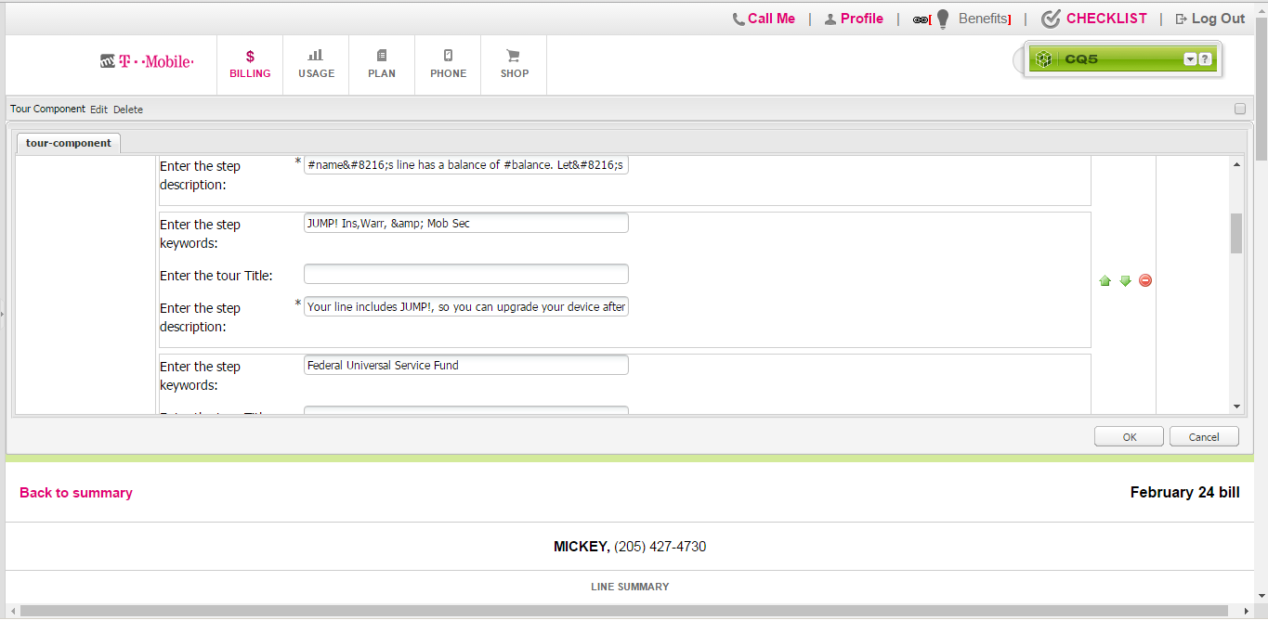

Below are the examples of text copy has to authored for this story

**US44945: [Continued] [Go Big] Onboarding - (Mobile) Bill Tour - Highlight Line Items**

**Example of a header keyword:**



|  |  |
| --- | --- |
| Field | Value |
| Enter the step keyword: | Plan |
| Enter the tour Title: |  |
| Enter the step description: | Your Simple Choice plan includes unlimited talk, text, and data on our network, including the specified amount of high-speed data, with no data overages, plus Data Stash. |
| Is Header | Checked |

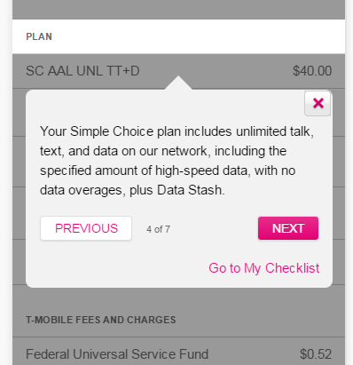

**Example of line item keyword:**



|  |  |
| --- | --- |
| Field | Value |
| Enter the step keyword: | Federal Universal Service Fund |
| Enter the tour Title: |  |
| Enter the step description: | Your bill includes a Federal Universal Service Fund charge to support access to telecommunication services for certain qualifying consumers. This charge is applied to all customer accounts. |
| Is Header | unchecked |

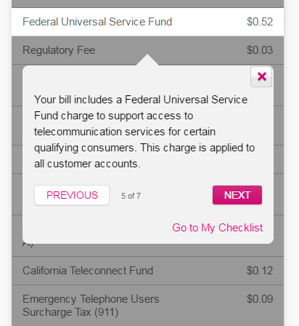

A few more examples of line items keywords   
Is Header will be unchecked for all the below

|  |  |
| --- | --- |
| Field | Value |
| Enter the step keyword: | JUMP! Ins,Warr, &amp; Mob Sec |
| Enter the tour Title: |  |
| Enter the step description: | Your line includes JUMP!, so you can upgrade your device after you’ve paid 50% of its price. |
| Is Header? | unchecked |
| Enter the step keyword: | Federal Universal Service Fund |
| Enter the tour Title: |  |
| Enter the step description: | Your bill includes a Federal Universal Service Fund charge to support access to telecommunication services for certain qualifying consumers. This charge is applied to all customer accounts. |
| Is Header? | unchecked |
| Enter the step keyword: | Utility Use |
| Enter the tour Title: |  |
| Enter the step description: | Your bill includes a Utility fee to supports your state&#39;s Public Utilities Commission, the governing body that regulates wireless rates, or your local authorities. This tax is required by local law and not imposed by T-Mobile. |
| Is Header? | unchecked |
| Enter the step keyword: | SCORE! |
| Enter the tour Title: |  |
| Enter the step description: | Your bill includes a monthly charge for a no-extra cost upgrade to a basic 4G smartphone after 6 months. Or, after 12 months at that rate, you&#39;ll get discounts on all new phones. |
| Is Header? | unchecked |
| Enter the step keyword: | Premium Voicemail |
| Enter the tour Title: |  |
| Enter the step description: | This fee covers the Voicemail to Text feature, which converts voicemails into text messages or emails, then sends them to your T-Mobile® Visual Voicemail inbox. |
| Is Header? | unchecked |
| Enter the step keyword: | T-Mobile CallerTunes Basic |
| Enter the tour Title: |  |
| Enter the step description: | This charge covers CallerTunes®, which lets you play incoming callers a special announcement or song instead of a ringtone they&#39;d normally hear. |
| Is Header? | unchecked |